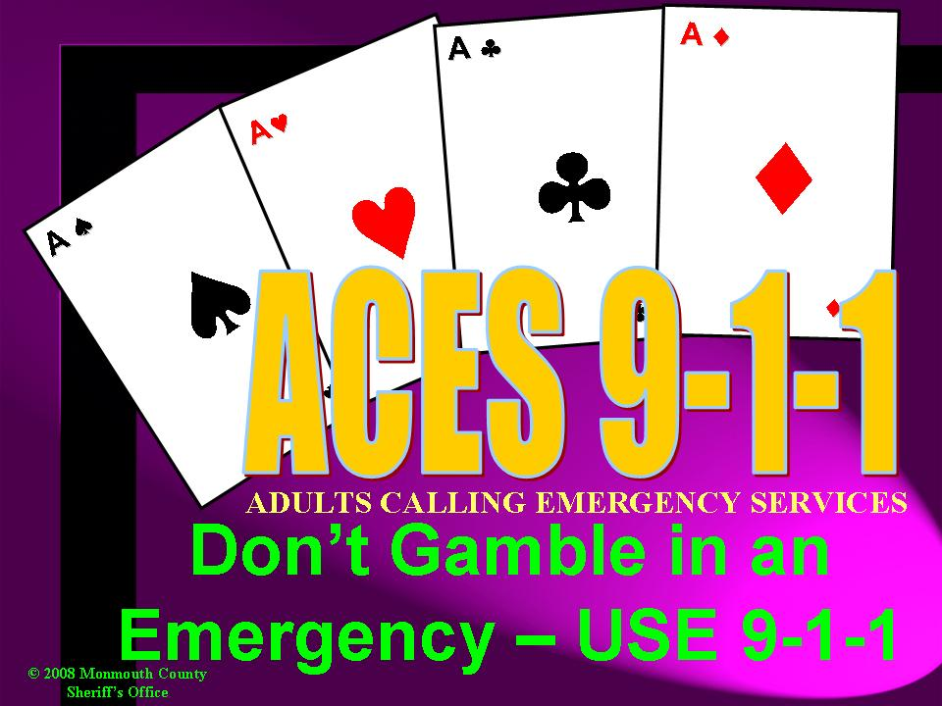

Subject: ACES 9-1-1 Adults Calling Emergency Services
Instructor (s): Kristin Aras and John J. Cuccia Jr.
Duration: 30 minutes
Audience: Adults

Unit Goals:

- To provide definition of 9-1-1 and how it works.
- To explain the Chain of Survival.
- To prepare student to contact 9-1-1 in case of an emergency.

Performance Objectives:

- Participant will understand 9-1-1 and how it works.
- Participants will understand Chain of Survival and each links responsibilities.
- Participants will understand the importance of when to call 9-1-1 emergency vs. non-emergency.
- Participants will be prepared to call 9-1-1 and provide the 9-1-1 operator the necessary information needed to dispatch emergency responders.

Support Materials:

- PowerPoint
- DVD – “ACES 9-1-1”
- PowerPoint projector and laptop computer
- Screen for projection
- DVD Player
- Audio Speakers
- Brochures
- ACES 9-1-1 Magnets

© 2008 – Monmouth County Sheriff’s Office – Communications Division

Unit Outline Teaching Strategy

I. Introduction Slide
A. Program Did you know…
B. Presenters - Over 170,000 9-1-1 calls of which
more than 27,000 are non-emergency
- Kids
- 9-1-1 started early 1990s
C. Real emergencies Slide House fire / Accident
D. Non-emergencies Slide Parking violations / cat in tree

II. Overview Slide
A. What is 911?
B. Chain of Survival Give Overview.
1. Citizen Link
2. 9-1-1 Operator
3. Emergency Responder
C. Senior Concerns

III. What is 9-1-1? Slide
A. Definition
B. 9-1-1 Network
1. Landline calls Explain how 9-1-1 calls are routed.
2. Cellular calls 9-1-1 center gets call after several rings.

IV. Introduce Chain of Survival Slide – Show Video 8:49 min.

V. Senior Concerns Slides
A. Senior Misconceptions Explain common misconceptions.
1. Bother / Burden
2. Wasting time of emergency
responders.
3. Causing a scene
4. Should or should not call

B. Should call 9-1-1 Slide
1. Chest Pains Explain denial during heart attacks.
2. Shortness of Breath
3. Severe Headache/Dizziness Explain could be a Stroke. Limited time.
4. Any uncontrolled bleeding Explain nosebleeds and issues with meds.
5. Any type of audible alarm Fire, Burg and CO Alarms.
6. Things out of ordinary Unexpected repair calls, people looking for
personal information.

C. Should not call 9-1-1 Slide and discussion
1. Power outages Top 5 non-emergency calls to 9-1-1.
2. Time or day check
3. Looking for phone number (411)
4. Can you call ___ for me?
5. Fireworks / Special events Where and what time do they begin.

VI. Questions Question and answer session
Before I conclude…

VII. Review Slide
A. Citizen Link Slide
1. Location Explain responsibilities
2. Identify Emergency
3. Call 9-1-1
4. Stay Calm
5. Speak Clearly
6. Give Information Explain importance of giving exact location.
7. Stay on Phone

B. 9-1-1 Operator Slide
1. Uniquely trained professional
2. Interrogates Callers
3. Determines appropriate level Explain difference between BLS/ALS.
of response
4. Dispatched appropriate Explain responders are dispatched while
emergency responders we are on the phone.
5. Provides crucial life saving Explain EMD can give CPR instructions etc.
instructions
6. Keeps emergency responders Explain that further questions asked by
updated 9-1-1 operator are relayed to responders.

C. Emergency Responder Slide
1. Police, Fire & EMS personnel Explain responsibilities
2. Responds quickly
3. Ensures safety

VIII. Conclusion Slide
A. Review Chain of Survival
B. Review brochure Hand out brochure
C. In the game of life, whatever cards Slide
you are dealt, in an emergency
ACES is always YOUR winning
hand.

